Toyota Hellas S.A. in accordance with TUV Hellas (TUV Nord) S.A. procedures has been certified for responding to the environmental management systems in line with the modified standard ISO 14001:2015.
Toyota Hellas is the 1st company of Inchcape plc group, that has included in the environmental management systems the whole Network of the Authorized Retailers and Repairers (66 sites in Greece).
This certification has been conducted in accordance with the TUV Hellas (TUV Nord) S.A. auditing and certification procedures and is subject to regular surveillance audits.
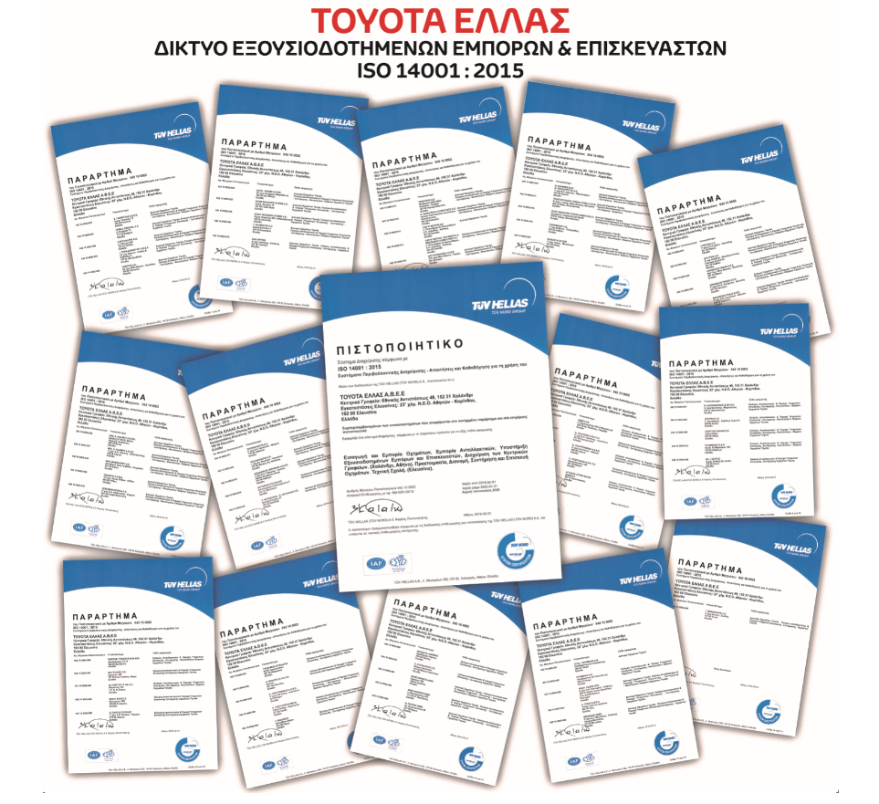

Toyota Hellas has also asked the electricity suppliers to supply electricity only from Renewable Resources, thus reducing its environmental footprint. The certificate (GREEN PASS) certifies that for the electricity consumed in all the facilities of TOYOTA Hellas, the supplier produces equal amount of energy coming from specific certified Renewable Energy Resources.

